TRIVIA CRACK
Caleb Questions 3
Video Games 3
League Of Legends 3
Call Of Duty 3
Minecraft 3
Elden Ring 3
Other 3
GTA V 3
Anime 3
Naruto 3
Jujutsu Kaisen 3
Dragon Ball 3
Geography 3
USA 3
Worldwide 3
Sports 3
NFL 3
NHL 3
NBA 3
UFC 3
Boxing 3
TV Shows 3
Game Of Thrones 3
Modern Family 4
Parks and Recreation 5
Always Sunny 5
The Office 6
Other 7
Movies 7
Music 9
College Sports 9
Celebrity Names 9
STEM 9
Math Questions 9
Science 9
Food 9

Caleb Questions
Q: When mixed together what are the TWO colors that make PURPLE?
A: Blue and Red
Q: At what temperature does water turn into ice?
A: 0 C or 32F
Q: What color is typically said to be the brightest?
A: Yellow
Q: Initially Green, what colors do leaves change to in the fall?
A: Red, Orange and Yellow
Q: What state has the highest population?
A: California
Q: What is the name of the talking panda in Jujutsu Kaisen?
A: Panda

Video Games

League Of Legends
Q: Which Champion has this quote “The forest holds many surprises.”
A: Zyra
Q: This Champ is known as the “Emperor of the Sands”
A: Azir
Q: In Lore, Who is Renektons Brother?
A: Nasus
Q: Which Character wields the Rod of Ages
A: Karthus Lightsbane
Q: Which Character does “Garrgoyle Stoneplate” belong to?
A: Galio
Q: Which two buyable items belong to Veigar?
A: Rabadons and morello
Q: This item is a part of a late game objectives body?
A: Nashors Tooth
Q: What two items belong to Gangplank?
A: Collector and Dead Mans Plate
Q: What character does “Edge of Night” belong to?
A: Talon
Q: What shop item belongs to Yasuo?
A: Stormrazor
Q: Which item is Irelia’s swords?
A: Trinity Force
Q: Which item resembles Shen’s Sword?
A: Sheen
Q: What does Katarina’s “Shunpo” translate to?
A: Blink Step
Q: Who is Katarina’s sibling?
A: Cassiopea
Q: There are 7 pairs of siblings in LOL name X?
A: Kayle - Morgana, Garen - Lux , Nasus - Renekton, Yasuo - Yone, Darius - Draven, and Vi - Jinx
Q: These 3 characters are siblings in LOL?
A: Anivia, Ornn and Volibear
Q: There are 5 champions that use health as a resource, who are they?
A: Vlad, Briar, Mundo, Olaf, Soraka and Zac
Q: On Jhin collector does how much damage instead of the original 999?
A: 4444
Q: This Characters Q abiity was originally a reference to spider man?
A: Amumu Bandage toss
Q: Which Character has the only SHIELD that protects from ONLY Attack Damage?
A: Camille
Q: Who is the only champion to “Dab” if you emote after a kill?
A: Quiyana
Q:
A:

Call Of Duty
Q: What was the 5th Call of Duty Game released?
A: World at War
Q: What number was Ghosts released?
A: 10th
Q: In MW2 what perk removed your secondary weapon?
A: One Man Army
Q: In MW2 what were the two 11 killstreaks?
A: AC-130 and Chopper Gunner
Q: In MW2 what were the two 7 killstreaks?
A: Attack Helicopter and Harrier
Q: Originally called the Harrier, what is the name of the killstreak in the new MW and MW2
A: VTOL Jet
Q: In COD Ghosts what weapon came equipped with a silencer when base?
A: Honeybadger
Q: In Black Ops, how many kills were the attack dogs?
A: 11
Q: Instead of killstreaks Black Ops 2 used?
A: Scorestreaks
Q: What was the blackbird/advanced UAV called in Black Ops 3?
A: HATR (High-altitude Telemetry and Reconnaissance)
Q: What was the Streak similar to attack dogs in Black Ops 3?
A: RAPS
Q: Call of Duty was officially ruined when this game brought in “jetpacks”?
A: Advanced Warefare
Q: What was the first COD game to cross platform? (xbox-ps)
A: Modern Warefare (New)

Minecraft
Q: What is the crafting recipe for a fence GATE?
A: 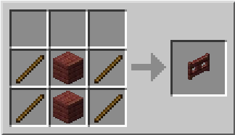
Q: What is the crafting recipe for Netherite Ingot?
A: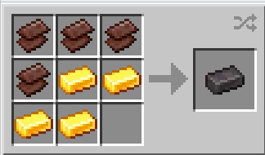
Q: What is the crafting recipe for an Item Frame?
A: 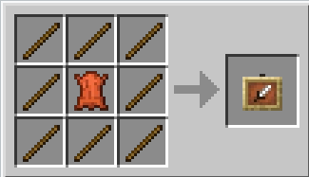
Q: What is the crafting recipe for a Redstone Lamp?
A: 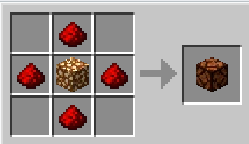
Q: What is the crafting recipe for a Crossbow?
A: 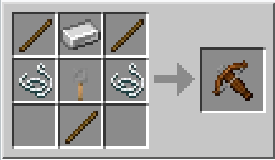
Q: What is the minimum number of obsidian pieces to create nether portal?
A: 10
Q: What is the crafting recipe for a cookie? And how many cookies do you get?
A: 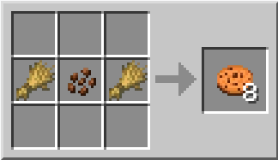
Q: How many hunger points does a steak heal? Each point is half the icon
A: 8 (each point is half an icon)
Q: What does drinking milk do?
A: Removes all buffs and debuffs
Q: What are the 2 ways to get mushroom soup?
A: Milk a mooshroom cow or craft
Q: Which mob drops the most XP when killed?
A: Ender Dragon(12000) (Any baby give mob(12) or chicken jockey(20))
Q: How do you brew an Awkward Potion?
A: Water bottle plus nether wart
Q: How do you craft a fermented spider eye?
A: 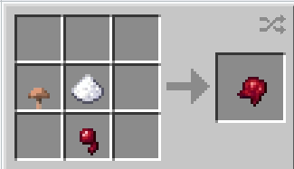
Q: What does Redstone do to a Level 1 Potion?
A: Increases the Duration
Q: What does Glowstone do to a Level 1 Potion?
A: Increase to a Level 2
Q: How many blocks can you fall without dying at full hearts? (No Armour)
A: 22 Blocks (23 Kills)
Q: How do you craft a map?
A: 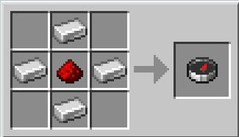
Q: How do you craft a Lead?
A: 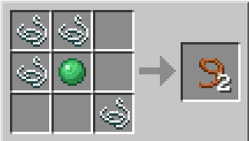
Q:
A:

Elden Ring
Q: Who was Malenia’s mother?
A: Queen Marika
Q: Who was Millicent’s mother?
A: Malenia
Q: Who was the daughter of Rennala and Radagon?
A: Ranni
Q: Who is the Half wolf son of Ranni?
A: Blaidd
Q: Who is the merchant near the two fingers in the roundtable hold?
A: Enia
Q: What is the name of the girl who give you the quests in volcano manor?
A: Tanith
Q: Who are the two bosses you encounter in Stormveil Castle?
A:Margit and Godrick
Q: There are 3 main bosses in the Academy, Name 2?
A: Red wolf raadagon, Carian Knight, Renalla
Q: Who is the southmost boss near castle morne?
A: Leonine Misbegoten
Q: Who are the 2 main bosses you need to complete in volcano manor?
A:Godskin Noble, Rukard
Q: What is the name of both the god skin bosses? Location?
A: Apostle and Noble, Mountain and volacano
Q:
A:
Q:
A:
Q:
A:

Other
Q: What is the name of the artificially superintelligent computer system in the Portal series?
A: GLaDOS
Q: Which character is the leader of the international crime syndicate, Shadowlaw, and the main boss in Street Fighter II?
A: Balrog/ M. Bison
Q: Known as Eggman in Japan, which character has been Sonic the Hedgehog's nemesis since the first game was released in 1991?
A: Dr. Robotnik
Q: What is the name of the first enemy players encounter in Super Mario Bros NES?
A: Goombas
Q: What is the name of the villain in the Legend of Zelda series?
A: Ganondorf
Q: Depicted as emperor of the fictional realm Outworld, who is one of the Mortal Kombat franchise's primary villains?
A: Shao Kahn (the Konqueror)
Q:
A:
Q:
A:
Q:
A:
Q:
A:
Q:
A:
Q:
A:
Q:
A:
Q:
A:
Q:
A:
Q:
A:
Q:
A:

GTA V
Q: In GTA Online what building allowed you to have more than 10 cars in a garage?
A: CEO Headquarters
Q: In the GTA online Casino, what is the max amount of chips you can bet at a time?
A: 50 000
Q: Name the first 5 heists released in GTA online IN ORDER
A: The Fleeca Job, Prison Break, Humane Labs, Serie A, Pacific Standard
Q: When customized this car turns into a retro Skyline GTR R33
A: Elegy Retro Custom
Q:What are the two websites you can buy cars from in GTA Online?
A: Legendary Motosports and Southern San Andreas Super Autos
Q: What was the most expensive car in game at the relase of GTA V
A: Truffade ADDER
Q: What was the name of the Real Estate company/website in GTA V?
A: Dynasty 8, Foreclosure and Executive
Q: What is the name of the place you buy guns and ammo?
A: Ammunation
Q: Released in the Gun Running update, this property allowed you to research upgrades for weapons and vehicles while also making passive income
A: Bunker
Q: Buying one of these properties would allow you to enter the military base with no wanted level
A: Hanger in the Airbase
Q: What is the mountain in GTA V called?
A: Mt Chumashe
Q: What are the 3 options at the end of the GTA V story mode?
A: Kill Michael, Kill Trevor or Deathwish
Q: What is the Strip Club called in GTA V?
A: Vanilla Unicorn
Q: What is Zachs favorite part of GTA V?
A: The Hookers
Q: What is the best car in GTA V? Wrong answers only/Free Points
A: Free Points/Rat Rod
Q:
A:
Q:
A:
Q:
A:
Q:
A:

Anime

Naruto
Q: What is the name of the Jutsu that allows the user to transfer objects and beings to and from another dimension?
A: Kamui
Q:
A:
Q:
A:
Q:
A:
Q:
A:
Q:
A:
Q:
A:
Q:
A:
Q:
A:
Q:
A:
Q:
A:
Q:
A:
Q:
A:
Q:
A:
Q:
A:
Q:
A:
Q:
A:
Q:
A:
Q:
A:
Q:
A:
Q:
A:
Q:
A:
Q:
A:
Q:
A:
Q:
A:
Q:
A:
Q:
A:
Q:
A:
Q:
A:
Q:
A:
Q:
A:
Q:
A:
Q:
A:
Q:
A:
Q:
A:
Q:
A:
Q:
A:
Q:
A:
Q:
A:
Q:
A:
Q:
A:

Jujutsu Kaisen
Q: What is the name of Megumi’s Dad?
A: Toji Fushiguro
Q: What is Nobara Kugisaki’s innate technique (kekkai genkai)?
A: Resonance
Q: Who refers to Itadori as his best friend/brother when meeting him the fist time?
A: Aoi Todo
Q: Who is the Jujutsu Sorcerer that consumes cursed spirits?
A: Sugaru Geto
Q: What is the name of Aoi Todo’s innate technique?
A: Boogie Woogie
Q: What is the name of the cursed spirit with a volcano head?
A: Jogo
Q: What is the name of the character the jujutsu sorcerers refer to as patch face?
A: Mahito
Q: What is the name of the character that’s technique has to do with a 7/3 split (Ratio Technique)?
A: Kento Nanami
Q:
A:
Q:
A:
Q:
A:
Q:
A:
Q:
A:
Q:
A:
Q:
A:
Q:
A:
Q:
A:
Q:
A:

Dragon Ball
Q:
A:
Q:
A:
Q:
A:
Q:
A:
Q:
A:
Q:
A:
Q:
A:
Q:
A:
Q:
A:
Q:
A:
Q:
A:
Q:
A:
Q:
A:
Q:
A:
Q:
A:

Geography

USA
Q: Name X of the territories of the USA
A: American Samoa, Guam, the Northern Mariana Islands, Puerto Rico, and the U.S. Virgin Islands
Q: What 3 States border California?
A: Oregon, Arizona and Nevada
Q: Which State has the highest population density?
A: New Jersey. (D.C technically)
Q: Which state is the Grand Canyon located in?
A: Arizona
Q: Order these States from most Northern to most Southern on a Map? Alaska, California, Colarado, Florida, Nebraska, Wisconsin
A: Alaska, Wisconsin, Nebraska, California, Colorado, Florida
Q: Rank these states by Population? Arkansas, Alabama, Illinois, Mass, Texas, Washington.
A: Texas, Illinois, Washington, Mass, Alabama, Arkansas
Q: What state, in the east central U.S., is home to Fort Knox and has a capital called Frankfort?
A: Kentucky
Q: what state officially recognized baked beans as the state food?
A: MASS
Q: What U.S. state was named after the French words for "green" and "mountain"?
A: Vermont
Q: In which U.S. state are both Mount Vernon and the Pentagon located?
A: Virginia
Q: In which state is the tallest mountain in the United States?
A: Alaska
Q: What U.S. state boasts the following rivers: the Guadalupe, Trinity, Rio Grande, Brazos, and Colorado?
A: Texas
Q: In 1780 which Northern U.S. state adopted a policy to gradually abolish slavery, the first state to do so?
A: Pennsylvania
Q:
A:
Q:
A:
Q:
A:
Q:
A:
Q:
A:
Q:
A:
Q:
A:
Q:
A:
Q:
A:
Q:
A:
Q:
A:

Worldwide
Q: 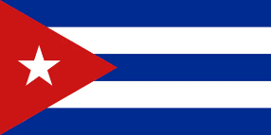
A: Cuba
Q: 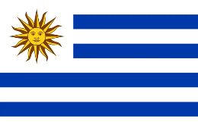
A: Uruguay
Q: 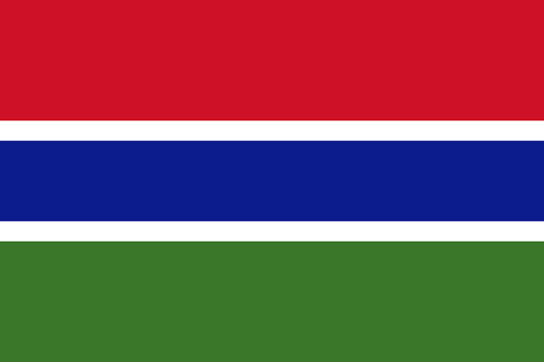
A: Gambia
Q: 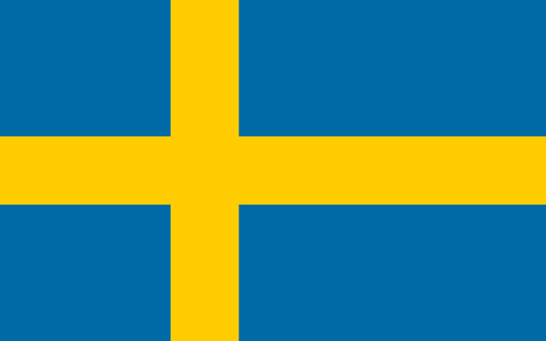
A: Sweden
Q: 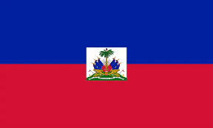
A: Haiti
Q: 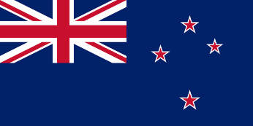
A: New Zealand
Q: 
A: Romania
Q: What is the only country that starts with the letter O?
A: Oman
Q: What is the only river that flows on both the north and south hemisphere. Crosses it twice
A: The Congo
Q:
A:
Q:
A:
Q:
A:
Q:
A:
Q:
A:
Q:
A:

Sports

NFL
Q:
A:
Q:
A:
Q:
A:
Q:
A:
Q:
A:
Q:
A:
Q:
A:
Q:
A:
Q:
A:
Q:
A:
Q:
A:
Q:
A:
Q:
A:
Q:
A:
Q:
A:
Q:
A:
Q:
A:
Q:
A:
Q:
A:
Q:
A:
Q:
A:
Q:
A:
Q:
A:
Q:
A:
Q:
A:
Q:
A:
Q:
A:
Q:
A:
Q:
A:
Q:
A:
Q:
A:
Q:
A:
Q:
A:
Q:
A:
Q:
A:
Q:
A:
Q:
A:
Q:
A:
Q:
A:
Q:
A:
Q:
A:
Q:
A:
Q:
A:

NHL
Q:
A:
Q:
A:
Q:
A:
Q:
A:
Q:
A:
Q:
A:
Q:
A:
Q:
A:
Q:
A:
Q:
A:
Q:
A:
Q:
A:
Q:
A:
Q:
A:
Q:
A:
Q:
A:
Q:
A:
Q:
A:
Q:
A:
Q:
A:
Q:
A:
Q:
A:

NBA
Q:
A:
Q:
A:
Q:
A:
Q:
A:
Q:
A:
Q:
A:
Q:
A:
Q:
A:
Q:
A:
Q:
A:
Q:
A:
Q:
A:
Q:
A:
Q:
A:
Q:
A:
Q:
A:
Q:
A:
Q:
A:
Q:
A:
Q:
A:
Q:
A:

UFC
Q:
A:
Q:
A:
Q:
A:
Q:
A:
Q:
A:
Q:
A:
Q:
A:
Q:
A:
Q:
A:
Q:
A:
Q:
A:
Q:
A:
Q:
A:
Q:
A:
Q:
A:
Q:
A:
Q:
A:
Q:
A:
Q:
A:
Q:
A:
Q:
A:
Q:
A:
Q:
A:
Q:
A:
Q:
A:
Q:
A:
Q:
A:
Q:
A:
Q:
A:
Q:
A:
Q:
A:
Q:
A:

Boxing
Q:
A:
Q:
A:
Q:
A:
Q:
A:
Q:
A:
Q:
A:
Q:
A:
Q:
A:
Q:
A:
Q:
A:
Q:
A:
Q:
A:
Q:
A:
Q:
A:
Q:
A:
Q:
A:
Q:
A:
Q:
A:
Q:
A:
Q:
A:
Q:
A:
Q:
A:
Q:
A:
Q:
A:
Q:
A:
Q:
A:
Q:
A:

TV Shows

Game Of Thrones
Q: Which House rules over High Garden?
A: House Tyrell
Q: What animal is on house Starks Banner?
A: Dire Wolf
Q:
A:
Q:
A:
Q:
A:
Q:
A:
Q:
A:
Q:
A:
Q:
A:
Q:
A:
Q:
A:
Q:
A:
Q:
A:
Q:
A:
Q:
A:
Q:
A:
Q:
A:
Q:
A:
Q:
A:
Q:
A:
Q:
A:
Q:
A:
Q:
A:
Q:
A:
Q:
A:

Modern Family
Q: What is the name of Jay’s wife?
A: Gloria
Q: What is the name of the gay couple?
A: Mitchell and Cameron
Q: What is the name of the gay couple's daughter?
A: Lily
Q: What is the name of the 3 Dunphy children?
A: Haley, Alex and Luke

Parks and Recreation
Q: What is the name of the neighboring county that Leslie hates?
A: Eagleton
Q: What is the name of the famous horse?
A: lil Sebastian
Q: What type of car does Donna drive?
A: Mercedes
Q: Chris Pratt plays which character?
A: Andy Dwyer
Q: Who shoots Ron on the hunting trip?
A: Tom
Q: What is Andys alter ego?
A: Bert Macklin FBI
Q: What is Tom and Jean’s club name?
A: The Snake Hole
Q: Who is Leslie’s Crush
A: Joe Biden

Always Sunny
Q:
A:
Q:
A:
Q:
A:
Q:
A:
Q:
A:
Q:
A:
Q:
A:
Q:
A:
Q:
A:
Q:
A:
Q:
A:

The Office
Q:
A:
Q:
A:
Q:
A:
Q:
A:
Q:
A:
Q:
A:
Q:
A:
Q:
A:
Q:
A:
Q:
A:
Q:
A:

Other
Q: What is the name of the cat that chases Tweety Bird?
A: Sylvester
Q:
A:
Q:
A:
Q:
A:
Q:
A:
Q:
A:
Q:
A:
Q:
A:
Q:
A:
Q:
A:
Q:
A:

Movies
Q: In LOTR, Gandalf has a horse that is the "lord of all horses", the greatest horses of Middle-earth. What is its name?
A: Shadowfax
Q: What horse is described as a hardworking, but naive and ignorant cart horse in George Orwell's 1945 novel Animal Farm?
A: Boxer
Q: What is the first name of J. K. Rowling, author of the Harry Potter books?
A: Joanne
Q:
A:
Q:
A:
Q:
A:
Q:
A:
Q:
A:
Q:
A:
Q:
A:
Q:
A:
Q:
A:
Q:
A:
Q:
A:
Q:
A:
Q:
A:
Q:
A:
Q:
A:
Q:
A:
Q:
A:
Q:
A:
Q:
A:
Q:
A:

Music
Q: How many times is “Black” and “Yellow” said in the song black and yellow by wiz khalifa
A: 99 times (closest wins)
Q: Who was Kurt Cobains Wife when he Died?
A: Courtney Love
Q: Kurt Cobain was a part of what band?
A: Nirvana
Q: A member of a very famous band, in the world of music is Richard Starkey more commonly known by what name?
A: Ringo Starr
Q: In 2012 which K-pop song by South Korean reached 1 billion views?
A: Gangnam Style
Q: Justin Bieber sang in Spanish for the first time in his career on a remix of which 2017 song
A: Despacito
Q: Which musical group released albums such as "Tango In The Night", "The Mask", and "Tusk"?
A: Fleetwood Mac
Q:
A:
Q:
A:
Q:
A:
Q:
A:
Q:
A:
Q:
A:
Q:
A:
Q:
A:
Q:
A:
Q:
A:
Q:
A:
Q:
A:
Q:
A:
Q:
A:
Q:
A:
Q:
A:
Q:
A:
Q:
A:
Q:
A:
Q:
A:
Q:
A:

College Sports
Q: Which 4 teams moved to the BigTen in last years conference realignment?
A: Oregon, UCLA, USC and Washington
Q: What is the UNH mascot name?
A: Wild E. Cat
Q:
A:
Q:
A:
Q:
A:
Q:
A:
Q:
A:
Q:
A:
Q:
A:
Q:
A:
Q:
A:

Celebrity Names
Q: Which Celebrity Plays Iron Man?
A: Robert Downy Jr
Q: Who TWO actors have played the character Rhodey/War Machine in the Marvel Cineamtic Universe, name them.
A: Terrance Howard, Don Cheadle
Q: Adam Savage and Jamie Hyneman are the co-hosts of, and known for, what popular television show?
A: MythBusters
Q:
A:
Q:
A:

STEM

Math Questions
Q: 0, 1, 1, 2, 3, 5, 8, 13, 21, 34, is the start of which famous sequence of numbers?
A: Fibonacci
Q: 1, 3, 6, 10, 15, 21, 28, 36, is an example of a Triangular Number Sequence, what number comes next?
A: 45
Q: What branch of mathematics is named for the Latin for pebble, and was devised by Sir Isaac Newton?
A: Calculus
Q:
A:
Q:
A:
Q:
A:
Q:
A:
Q:
A:
Q:
A:
Q:
A:
Q:
A:
Q:
A:
Q:
A:
Q:
A:
Q:
A:

Science
Q: Atoms of the same chemical element that have different atomic mass are known as what?
A: Isotopes
Q: A, T, and C, are three letters of the English alphabet which represent the bases of DNA used in the Genetic Code. What's the fourth?
A: G
Q: What is the medical name fora hiccup?
A: singultus
Q: Associated with eating or drinking cold things, Sphenopalatine ganglioneuralgia is the medical term for which pain?
A: Brain Freeze
Q: Which Vitamin do humans get from the sun?
A: D
Q: What material are computer processors traditionally made using?
A: Silicon
Q:
A:
Q:
A:
Q:
A:
Q:
A:
Q:
A:
Q:
A:
Q:
A:
Q:
A:
Q:
A:

Food
Q: What are Ristretto, Cortado, Doppio, and Affogato types of?
A: Coffee
Q: What are Burrata, Stracciatella, Jarlsberg, and Asiago types of?
A: Cheese
Q: What are Arran Pilot, Yukon Gold, Melody, and Ulster Chieftain types of?
A: Potato
Q: What are Bomba, Wild, Jasmine, and Glutinous types of?
A: Rice
Q: What drink is made from espresso coffee, steamed milk and chocolate?
A: Mocha
Q: A Pina Colada contains coconut milk, pineapple juice, and which alcoholic spirit?
A: Rum
Q:
A:
Q:
A:
Q:
A:
Q:
A:
Q:
A:
Q:
A:
Q:
A:
Q:
A:
Q:
A:
Q:
A:
Q:
A:
Q:
A:
Q:
A:
Q:
A:
Q:
A:

Numbers
Q: How many times are “Black” and/or “Yellow” said in the song Black and Yellow by Wiz Khalifa
A: 99 times
Q: Price of 1995 G-wagon?
A: 65K
Q: Number of McDonalds in New York state?
A: 699
Q: Number of McDonalds in North Dakota?
A: 22
Q: Number of Dunkin’s in California?
A: 141
Q: Number of Dunkin in New York?
A: 1426
Q: Price of Gas in California (Regular)
A: $4.634
Q:
A:
Q:
A:
Q:
A:
Q:
A:
Q:
A:
Q:
A:
Q:
A:

